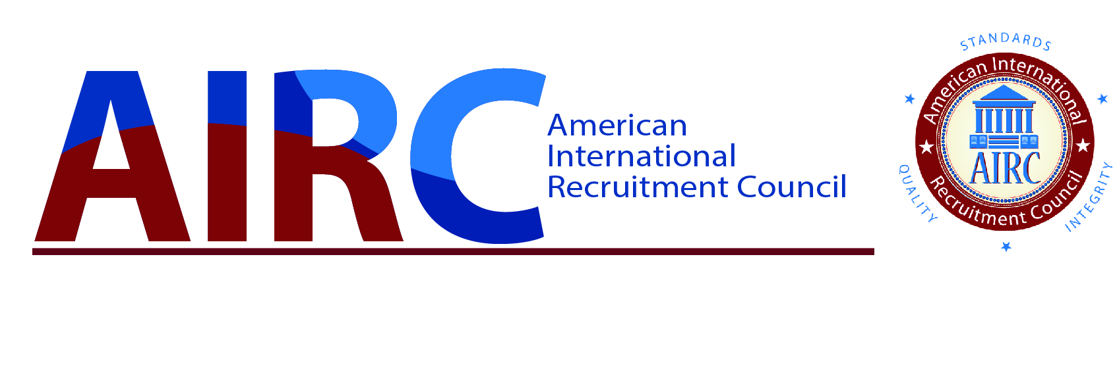

April 16, 25

[Name as it appears on Passport]
Date of Birth:
Passport No:

Dear Ms./Mr.,
This is an invitation to attend the Sixteenth Annual Conference of the American International Recruitment Council (AIRC) to be held in Atlanta, Georgia, United States, December 3-6, 2025.
AIRC is a non-profit 501(c)3 standards body registered with the U. S. Department of Justice and created by the U.S. higher education community. AIRC’s mission is to safeguard the interests of students and enrolling institutions through the promotion of ethical, standards based, international recruitment strategies. You, Ms./Mr. [name], represent an AIRC Certified Agency Member, [agency name].

The AIRC conference should be considered an excellent opportunity to discuss best practices in recruitment and to network with American higher education professionals. As such, attendance should be considered vital to your interests.
Please do not hesitate to contact me should you or any colleagues have questions regarding our conference.
Sincerely,
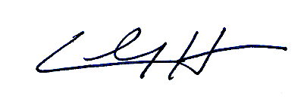
Clay Harmon
Executive Director

